WRITING AN EXPRESSION
Pearson Edexcel - Thursday 6 June 2019 - Paper 2 (Calculator) Foundation Tier

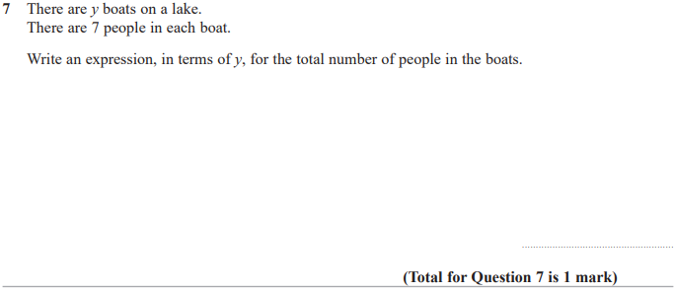

Pearson Edexcel – Specimen 2 - Paper 1 (Non-Calculator) Foundation Tier

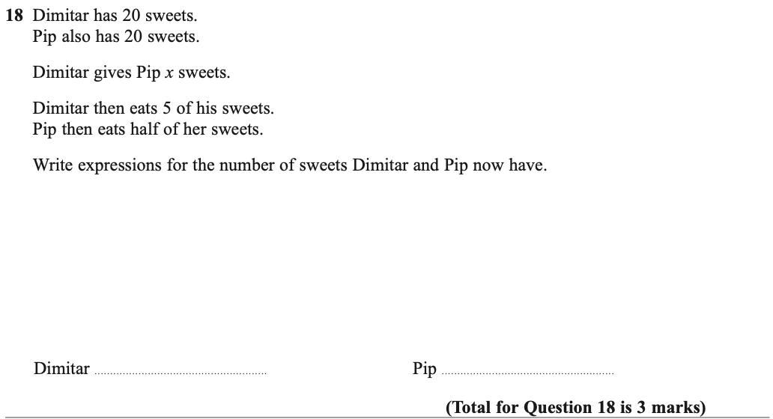

Pearson Edexcel – Specimen 2 - Paper 3 (Calculator) Foundation Tier

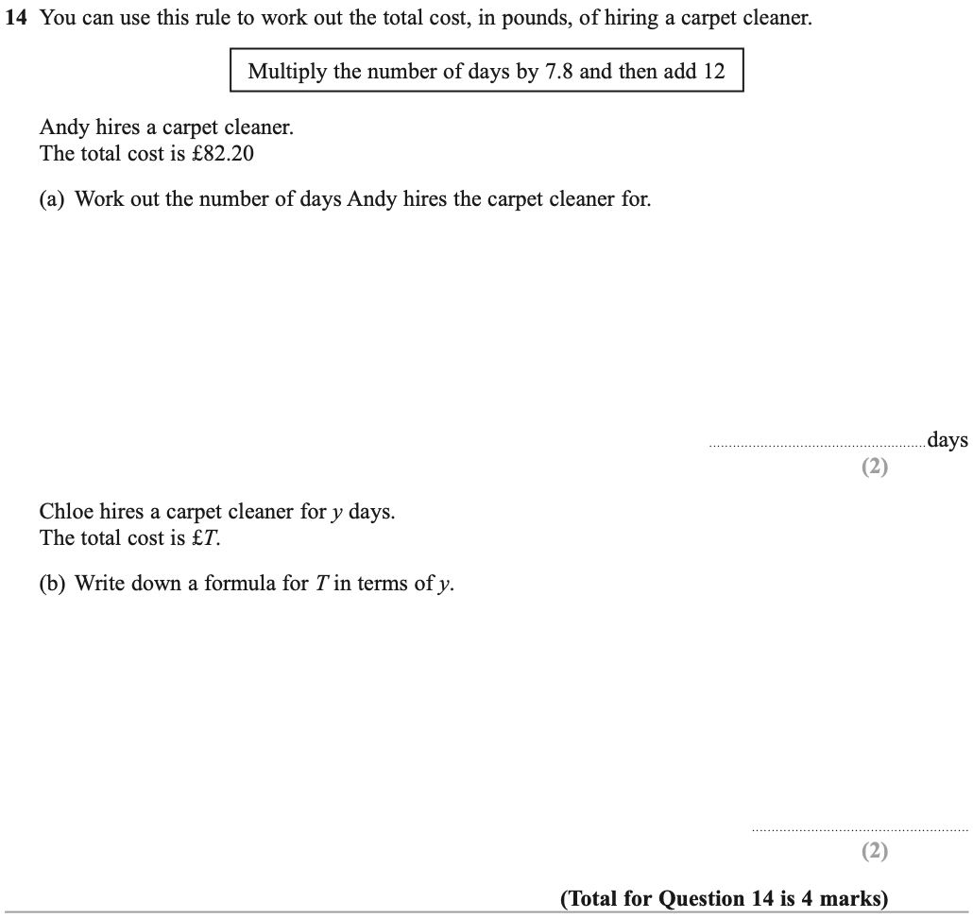

OCR – Tuesday 03 November 2020- Morning - Paper 1 (Calculator) Foundation Tier

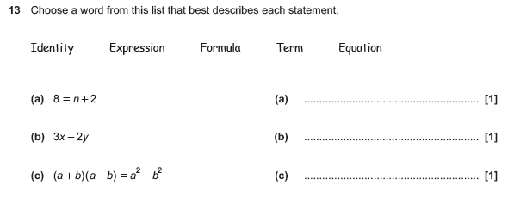

OCR Thursday 7 June 2018 – Morning (Non Calculator) Foundation Tier
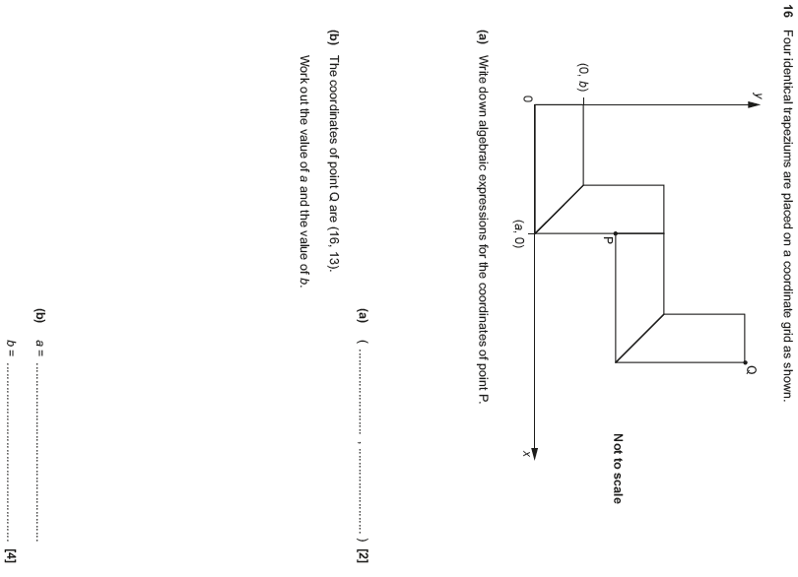

OCR Tuesday 12 June 2018– Morning (Calculator) Foundation Tier

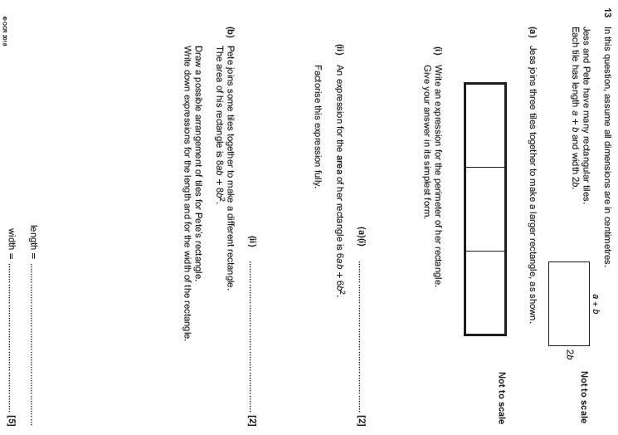

OCR Monday 6 November 2017– Morning (Calculator) Foundation Tier

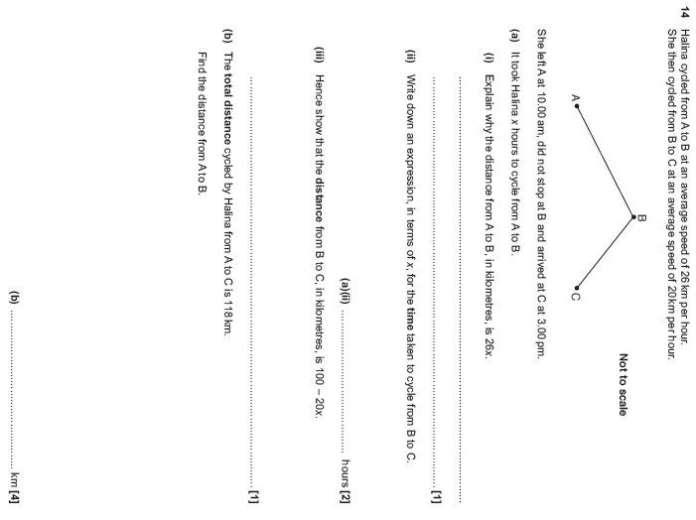

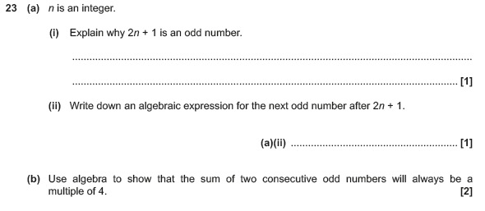

Pearson Edexcel –Sample Papers - Paper 2 (Calculator) Foundation Tier

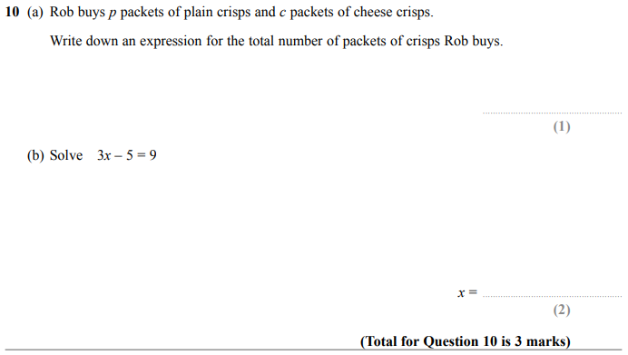

AQA Monday 8 June 2020 – Morning (Calculator) Foundation Tier

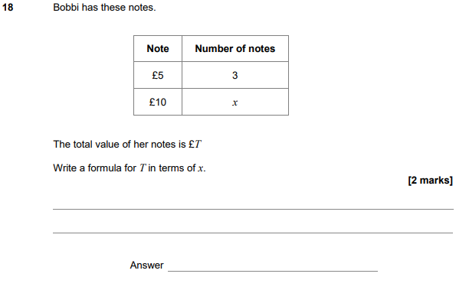

AQA Thursday 7 June 2018 – Morning (Calculator) Foundation Tier

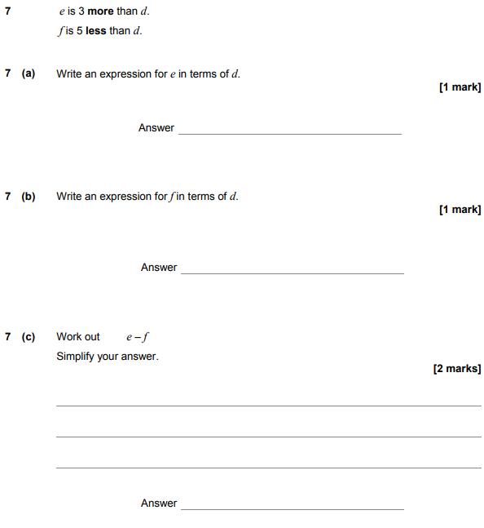

AQA Tuesday 12 June 2018 – Morning (Calculator) Foundation Tier

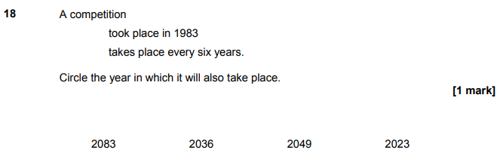

AQA Monday 6 November 2017 – Morning (Calculator) Foundation Tier

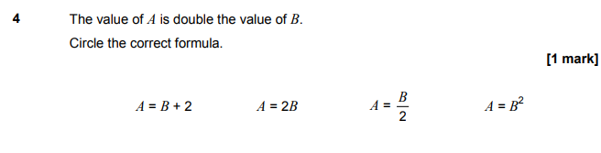
AQA Tuesday 13 June 2017 Morning– Morning (Calculator) Foundation Tier

